|  |  |  |
| --- | --- | --- |
|  | **CMPS 312 Project Phase 2 – Data Layer using Firestore, Firebase Storage and local SQLite Database (10% of the course grade)** | |
| **Group Id:** | | T3 |
| **Group Members:** | | * **Fahrel Hidayat** - 202206836 - [fh2206836@qu.edu.qa](mailto:fh2206836@qu.edu.qa) * **Marcus Monteiro** - 202206892 - [mm2206892@qu.edu.qa](mailto:mm2206892@qu.edu.qa) * **Mohd Bashar** - 202205153 - [mb2205153@qu.edu.qa](mailto:mb2205153@qu.edu.qa) * **Mohammed Alam** - 202211429 - [ma2211429@qu.edu.qa](mailto:ma2211429@qu.edu.qa) |

# Grading Rubric - In the Functionality column please specify either:

***Working (completed x%)*, *Not Working (completed x%)* or *Not done*.**

|  |  |  |  |  |
| --- | --- | --- | --- | --- |
| Criteria | | % | Functionality* | Quality of the implementation |
| 1. **Database Design:** Firestore database schema diagram and SQLite database schema diagram | | 5% | ***Working (completed 100%)*** |  |
| **2) Design and implement** | | **90%** |  |  |
|  | U1 – Signup and Signin using Firebase Authentication | 10 | ***Working (completed 100%)*** |  |
| U2 - YalaPay Dashboard | 8 | ***Working (completed 50%)*** |  |
| U3 - List/Search/Add/ Update and Delete a customer:  1. List Customers (5 pts)  2. Search Customers (5 pts)  3. Add Customer (5 pts)  4. Update Customer (4 pts)  5. Delete Customer (3 pts) | 22 | ***Working (completed 100%)*** |  |
| U4 - List/Search/Add/ Update and Delete an Invoice  1. List Invoices (5 pts)  2. Search Invoices (5 pts)  3. Add Invoice (5 pts)  4. Update Invoice (4 pts)  5. Delete Invoice (3 pts) | 22 | ***Working (completed 100%)*** |  |
| U5 - List/Search/Add/ Update and Delete payments for an invoice  1. List Payments (5 pts)  2. Search Payments (5 pts)  3. Add Payment including attach a cheque image (9 pts)  4. Update Payment including attach a cheque image (8 pts)  5. Delete Payment (3 pts) | 30 | ***Working (completed 80%)*** |  |
| U6 - Manage Cashing Cheques  1. Add Cheques Deposit (10 pts)  2. List Cheque Deposits (5 pts)  3. Update Cheques Deposit (15 pts) | 30 | ***Working (completed 100%)*** |  |
| U7 - Invoices Report | 8 |  |  |
| U8 - Cheques Report | 8 |  |  |
| **3) Testing documentation** using screen shots illustrating the app testing.  - Discussion of the project contribution of each team member [-10pts if not done] | | 5% | ***Working (completed 100%)*** |  |
| **Total** | | 100 |  |  |
| Copying and/or plagiarism or not being able to explain or answer questions about the implementation | | -  100 |  |  |

**\* Possible grading for functionality** - ***Working*** (get 70% of the assigned grade), ***Not*** ***working*** (lose 40% of assigned grade and ***Not done*** (get 0). The remaining grade is assigned to the quality of the implementation.

In case your implementation is not working then 40% of the grade will be lost and the remaining 60% will be determined based on of the code quality and how close your solution to the working implementation.

Solution quality also includes meaningful naming of identifiers (according to Flutter/Dart naming conventions), no redundant code, simple and efficient design, clean implementation without unnecessary files/code, use of comments where necessary, proper code formatting and indentation.

**Marks will be reduced** forcode duplication, poor/inefficient coding practices, poor naming of identifiers, unclean/untidy submission, and unnecessary complex/poor user interface design.

# Database Design

# Firestore database schema diagram

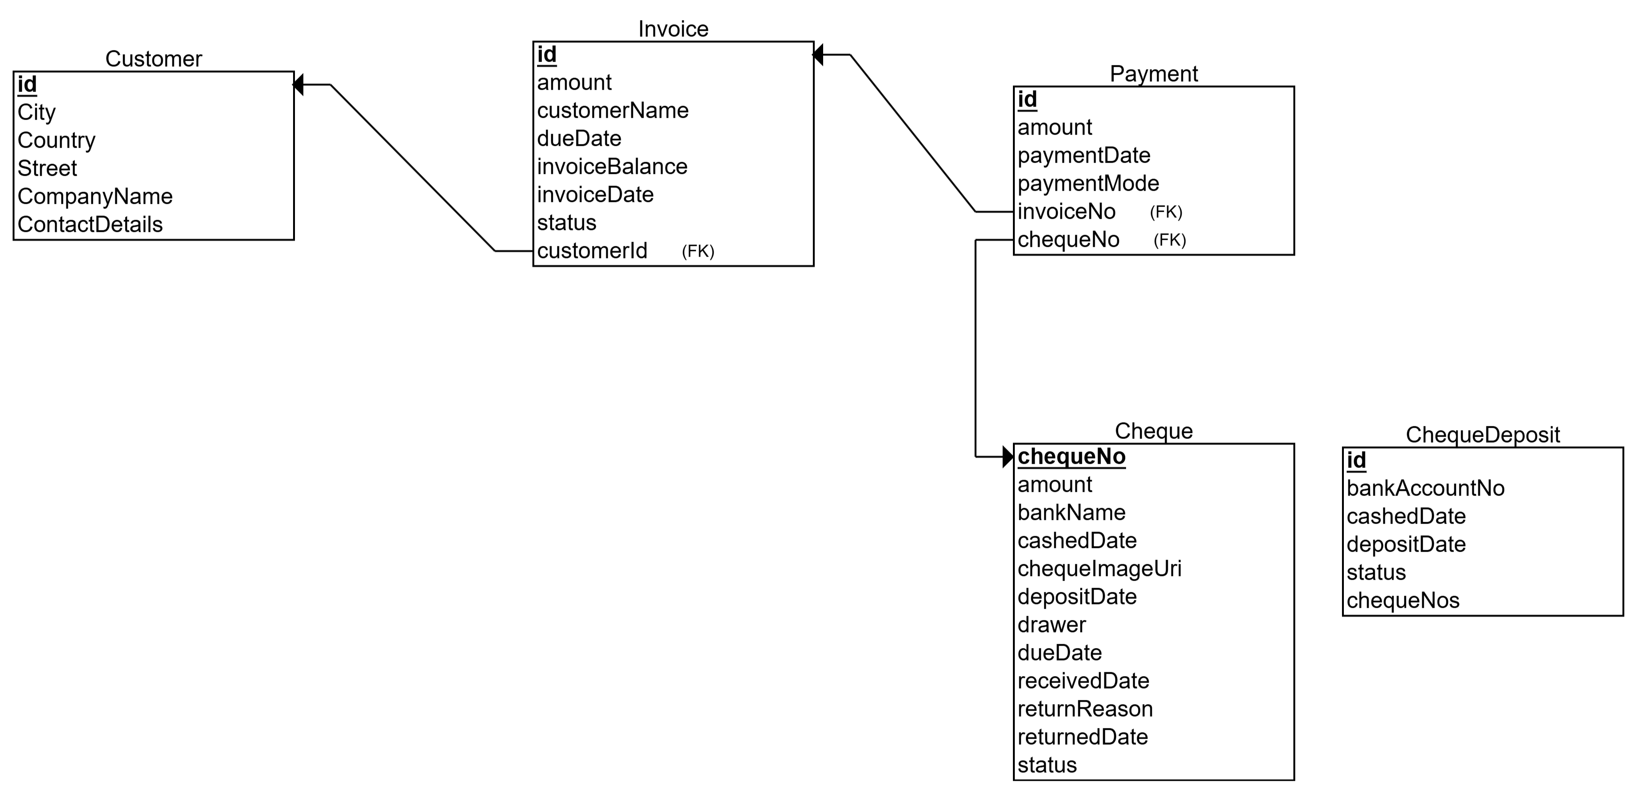

# SQLite database schema diagram

# Testing

# U1 – Signup and Signin using Firebase Authentication

|  |  |
| --- | --- |
| Create Account | Account Yahya Created |

|  |  |
| --- | --- |
| Logging in with Yahya Account | Logged In |

# U2 - YalaPay Dashboard

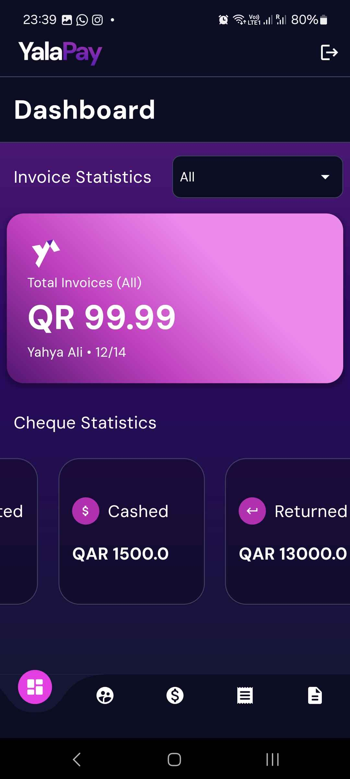

# U3 - List/Search/Add/ Update and Delete a Customer

# List Customers

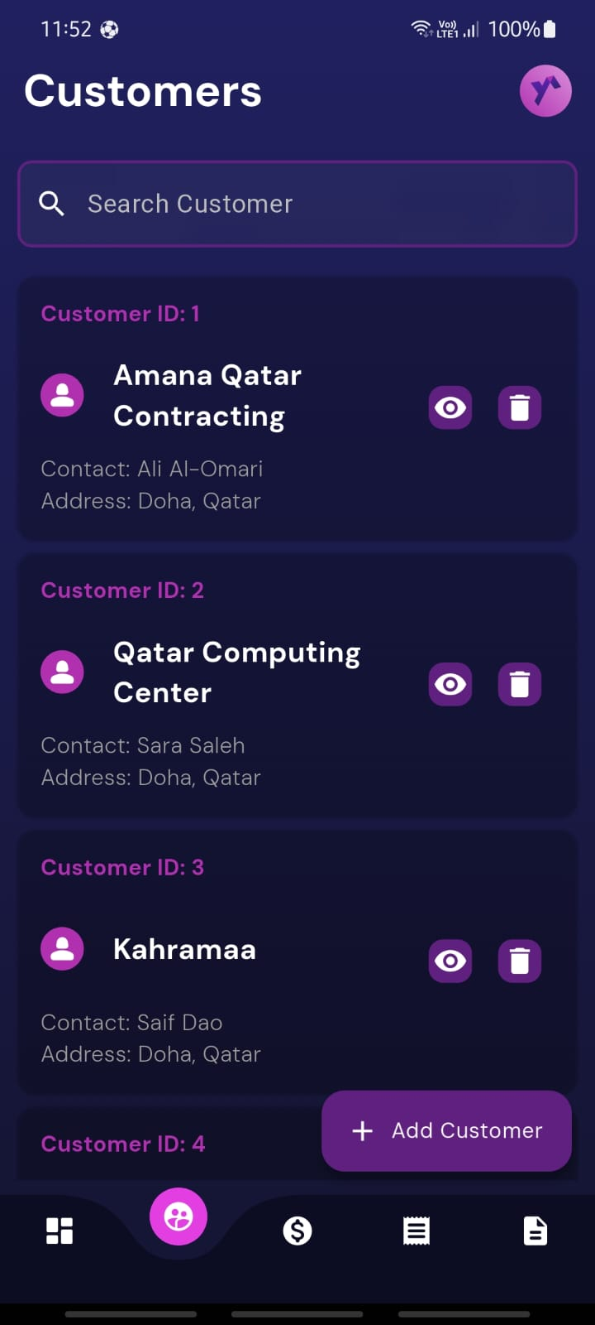

# Search Customers

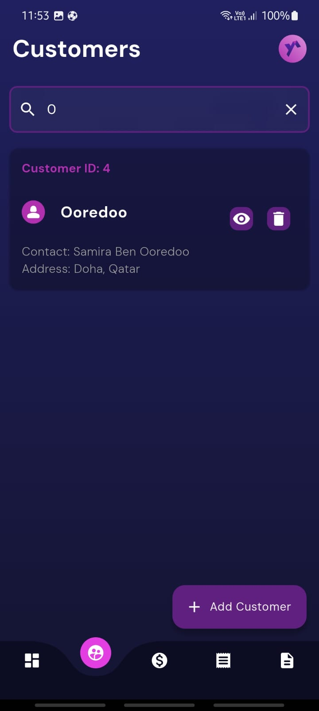

# Add Customer

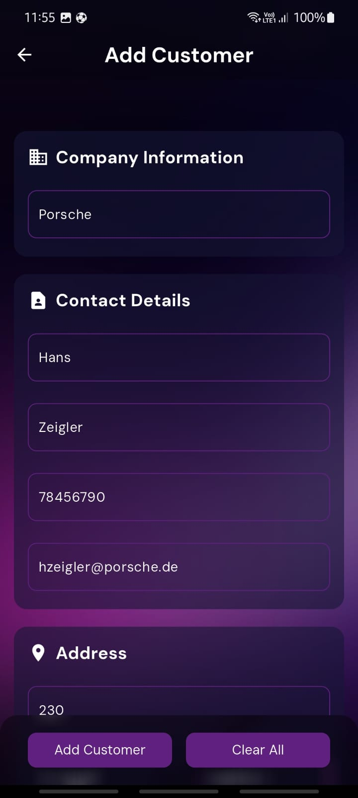 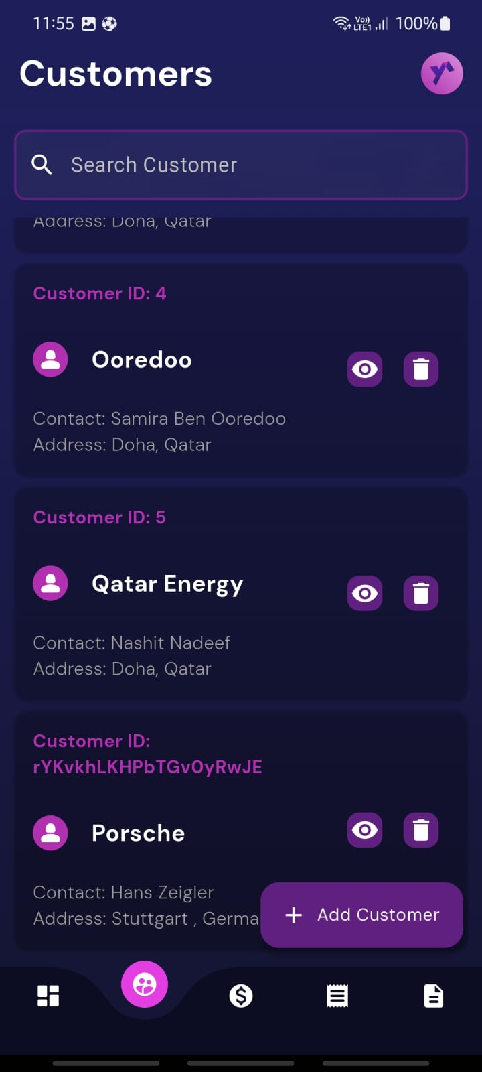

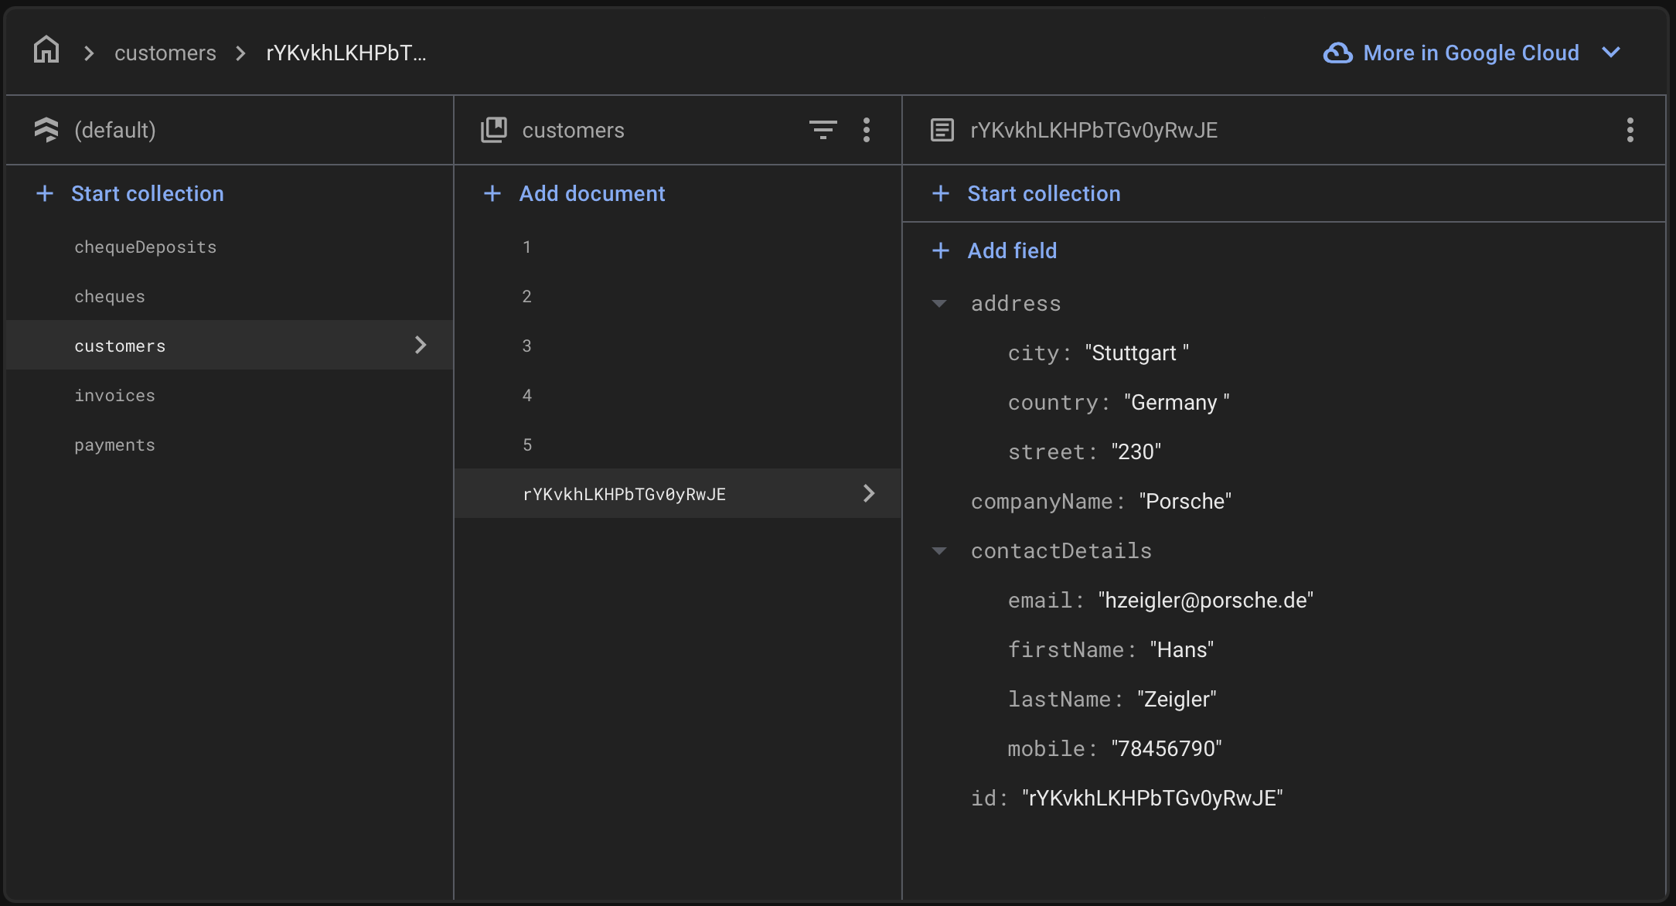

# Update Customer

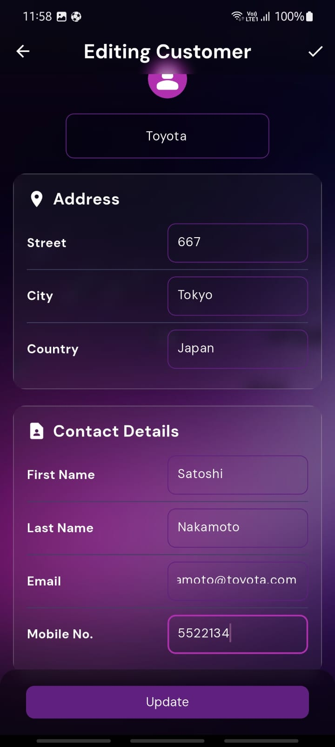 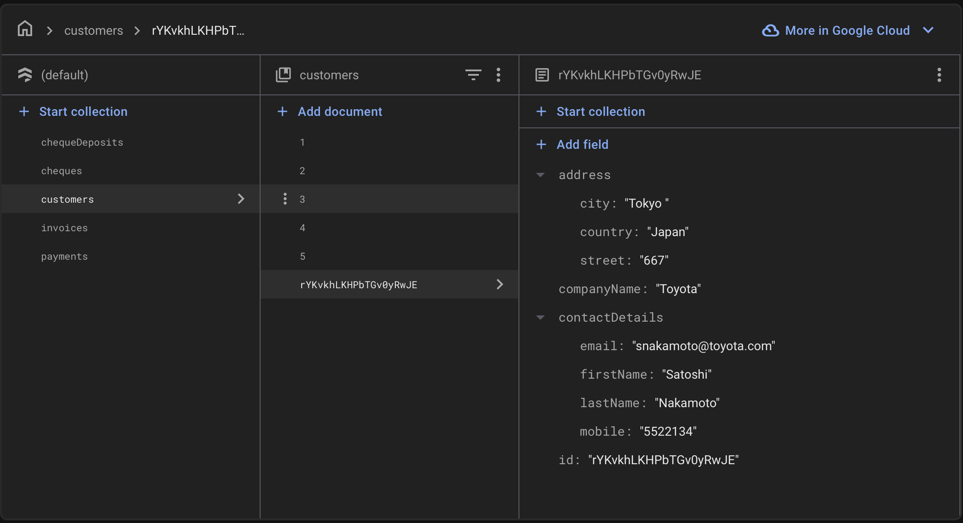

# Delete Customer

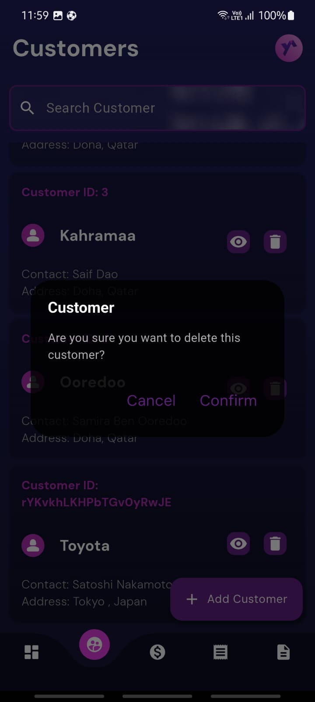 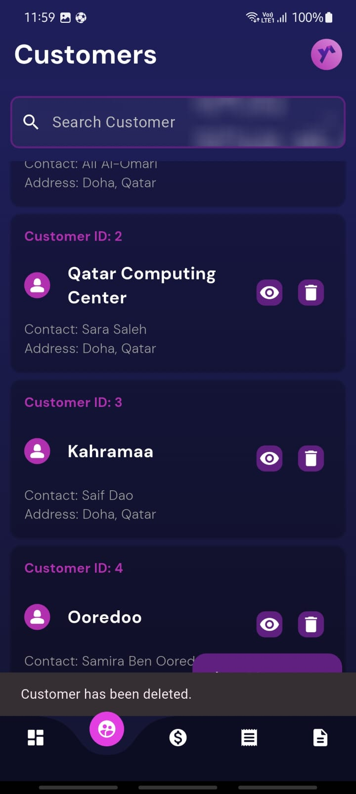

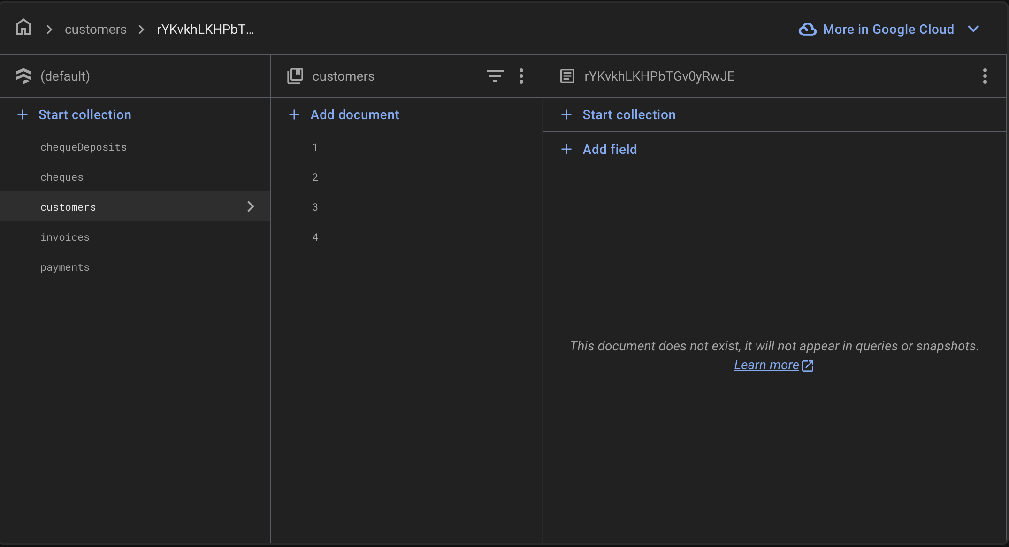

# U4 - List/Search/Add/ Update and Delete an Invoice

# 2.2.1 List Invoices

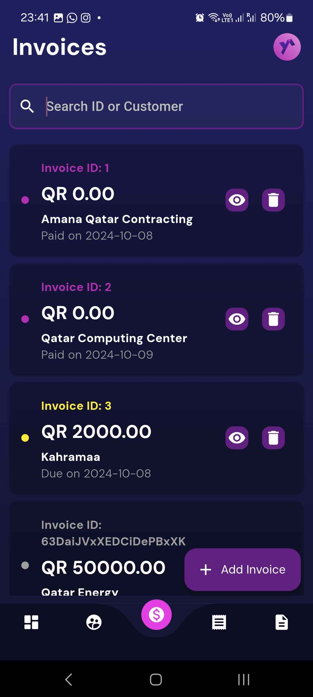

# 2.2.2 Search Invoices



# 2.2.3 Add Invoice

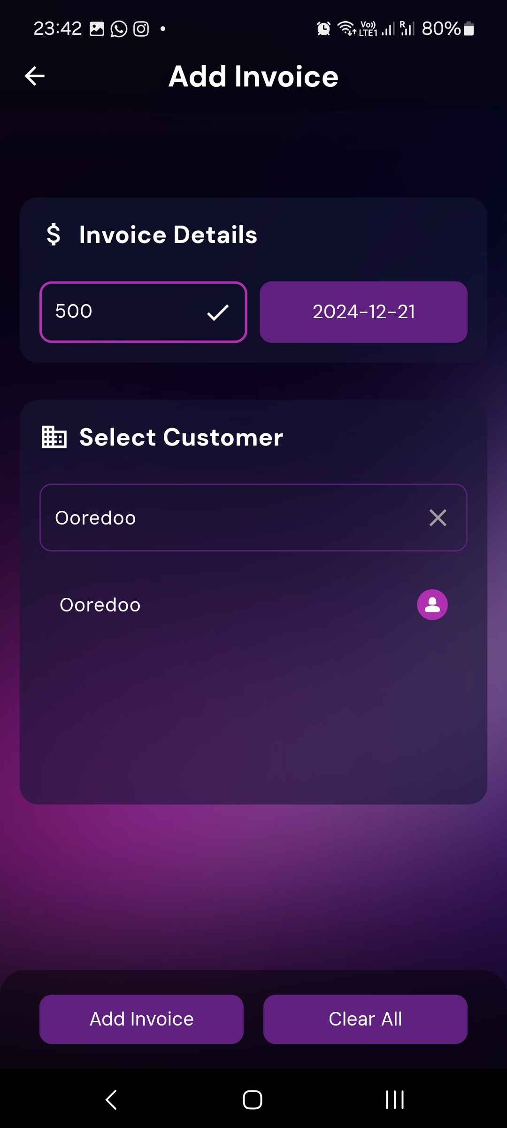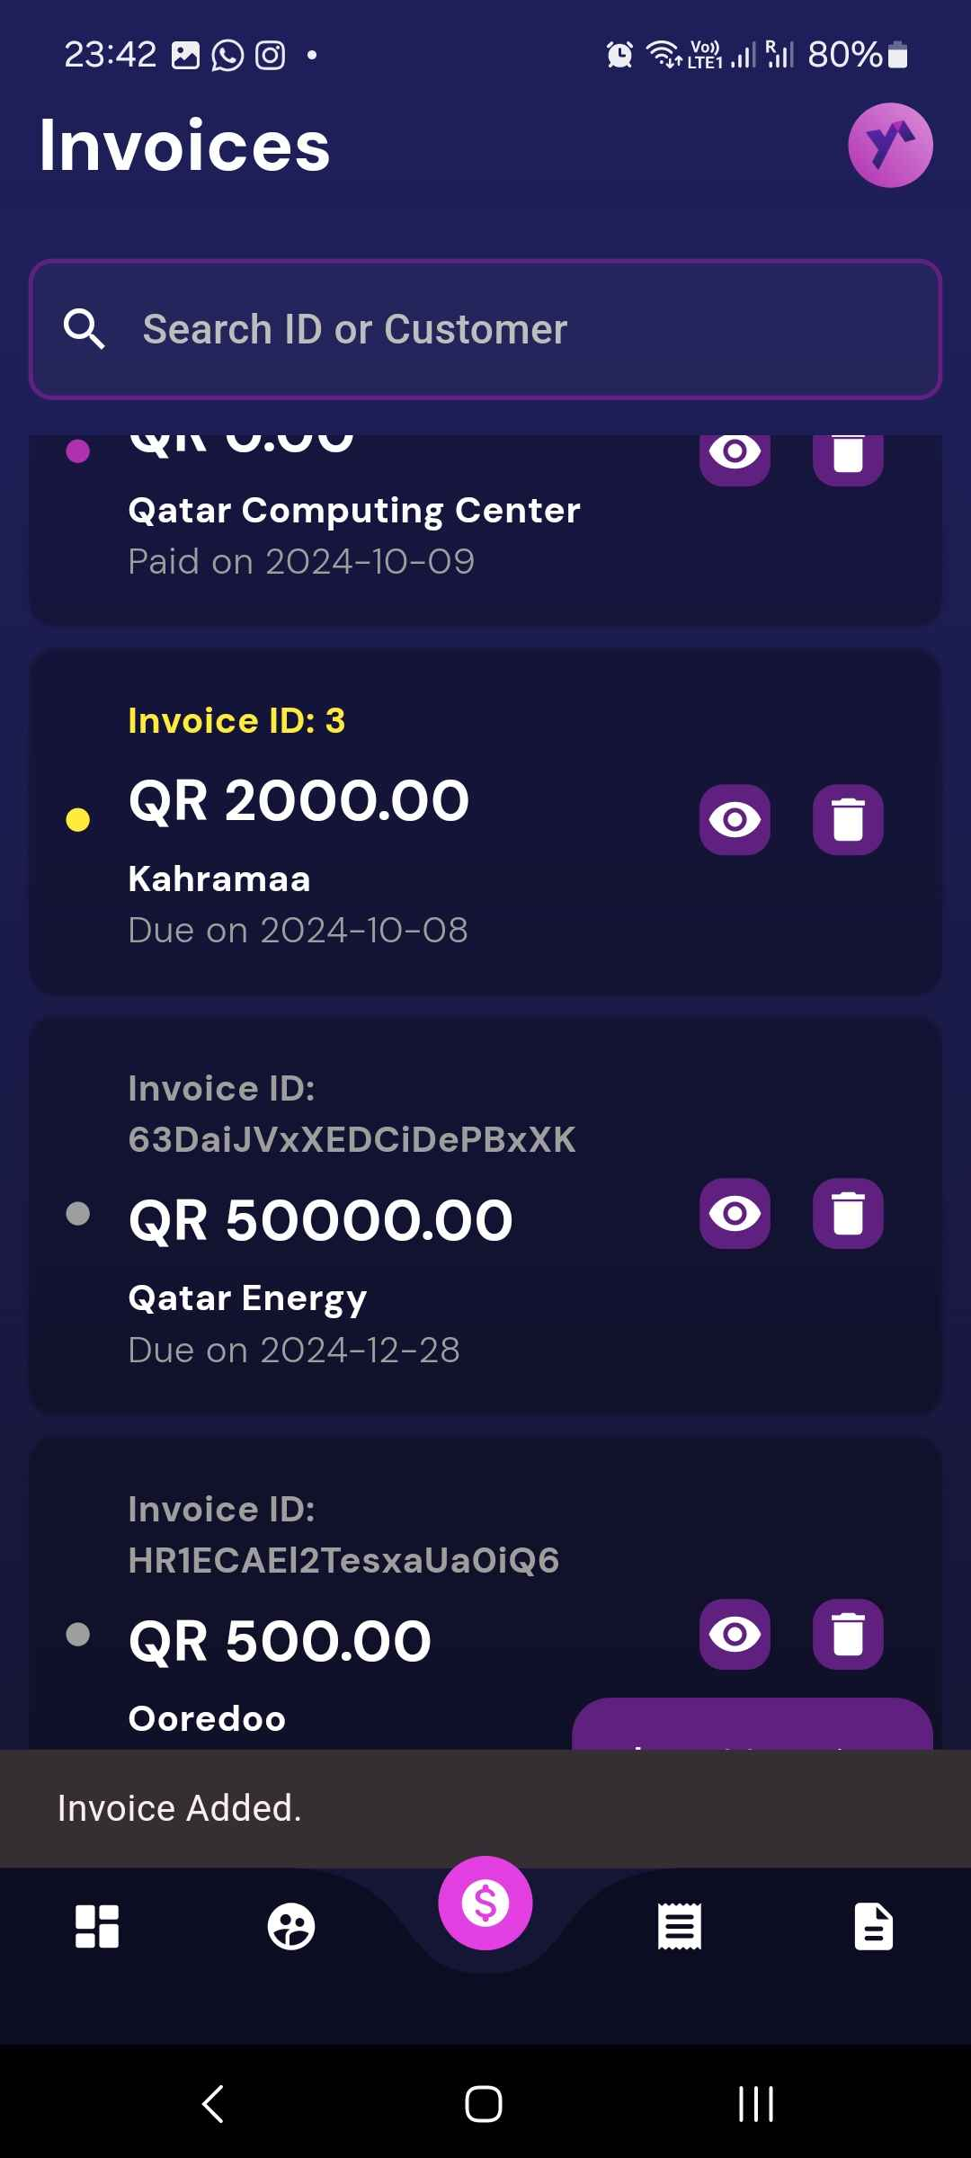

# 2.2.4 Update Invoice

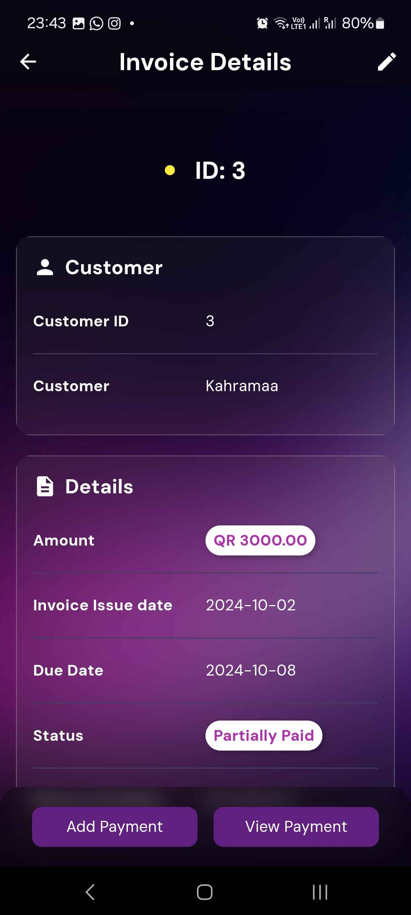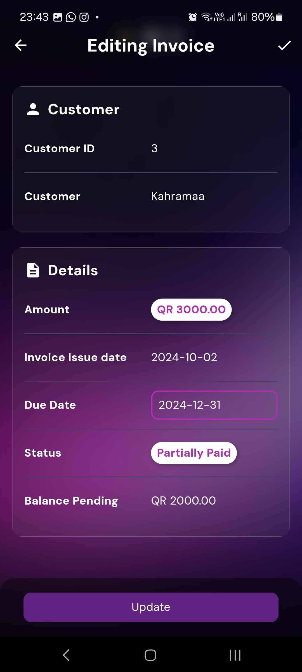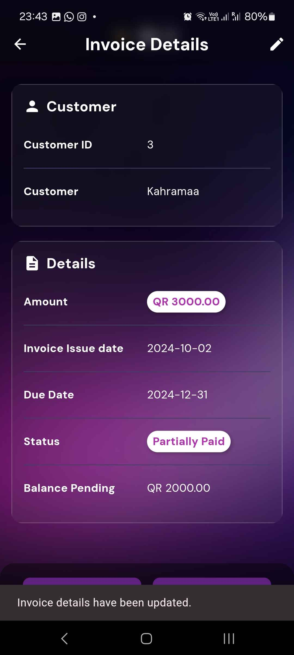

# 2.2.5 Delete Invoice

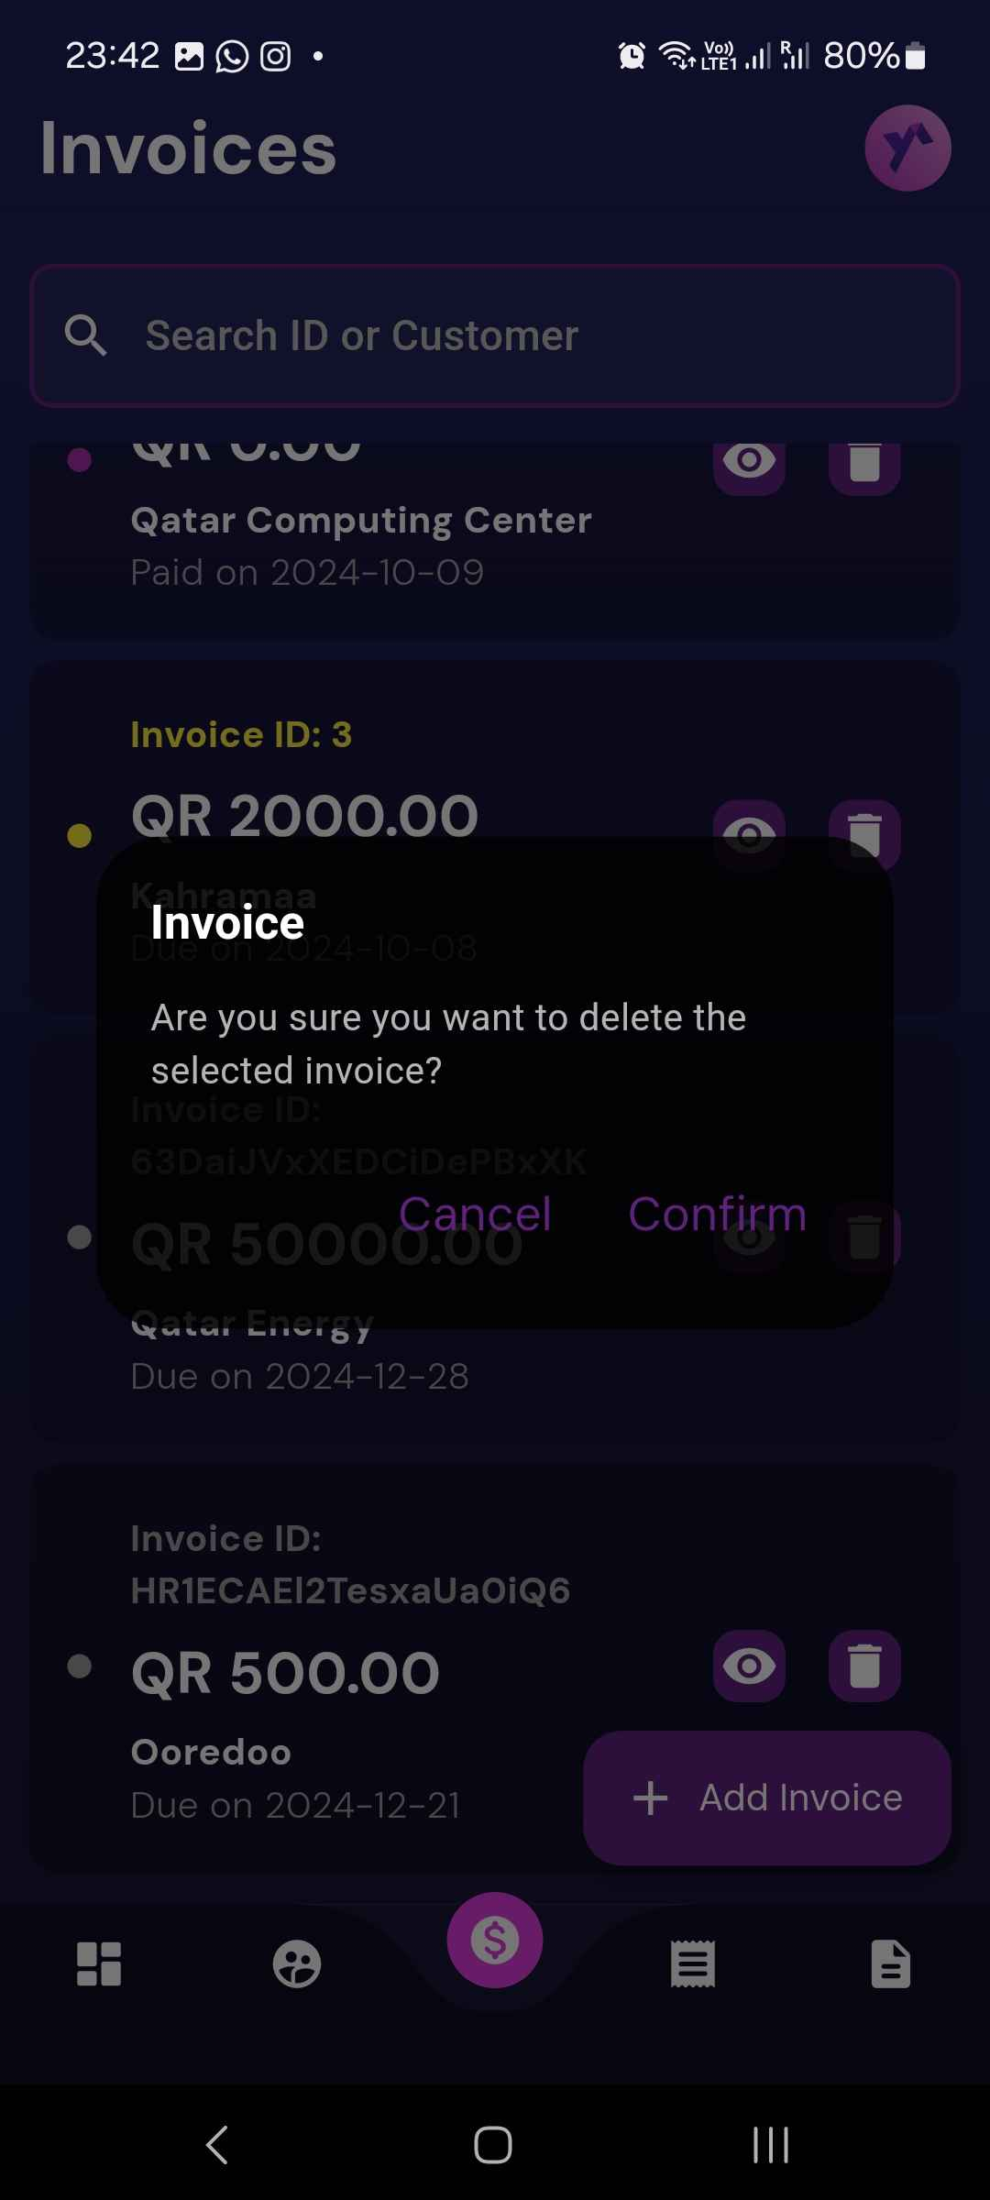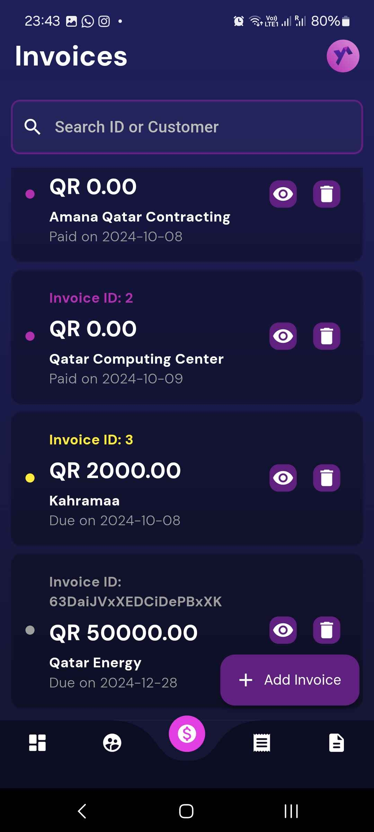

# U5 - List/Search/Add/ Update and Delete payments for an invoice

# 2.3.1 List Payments

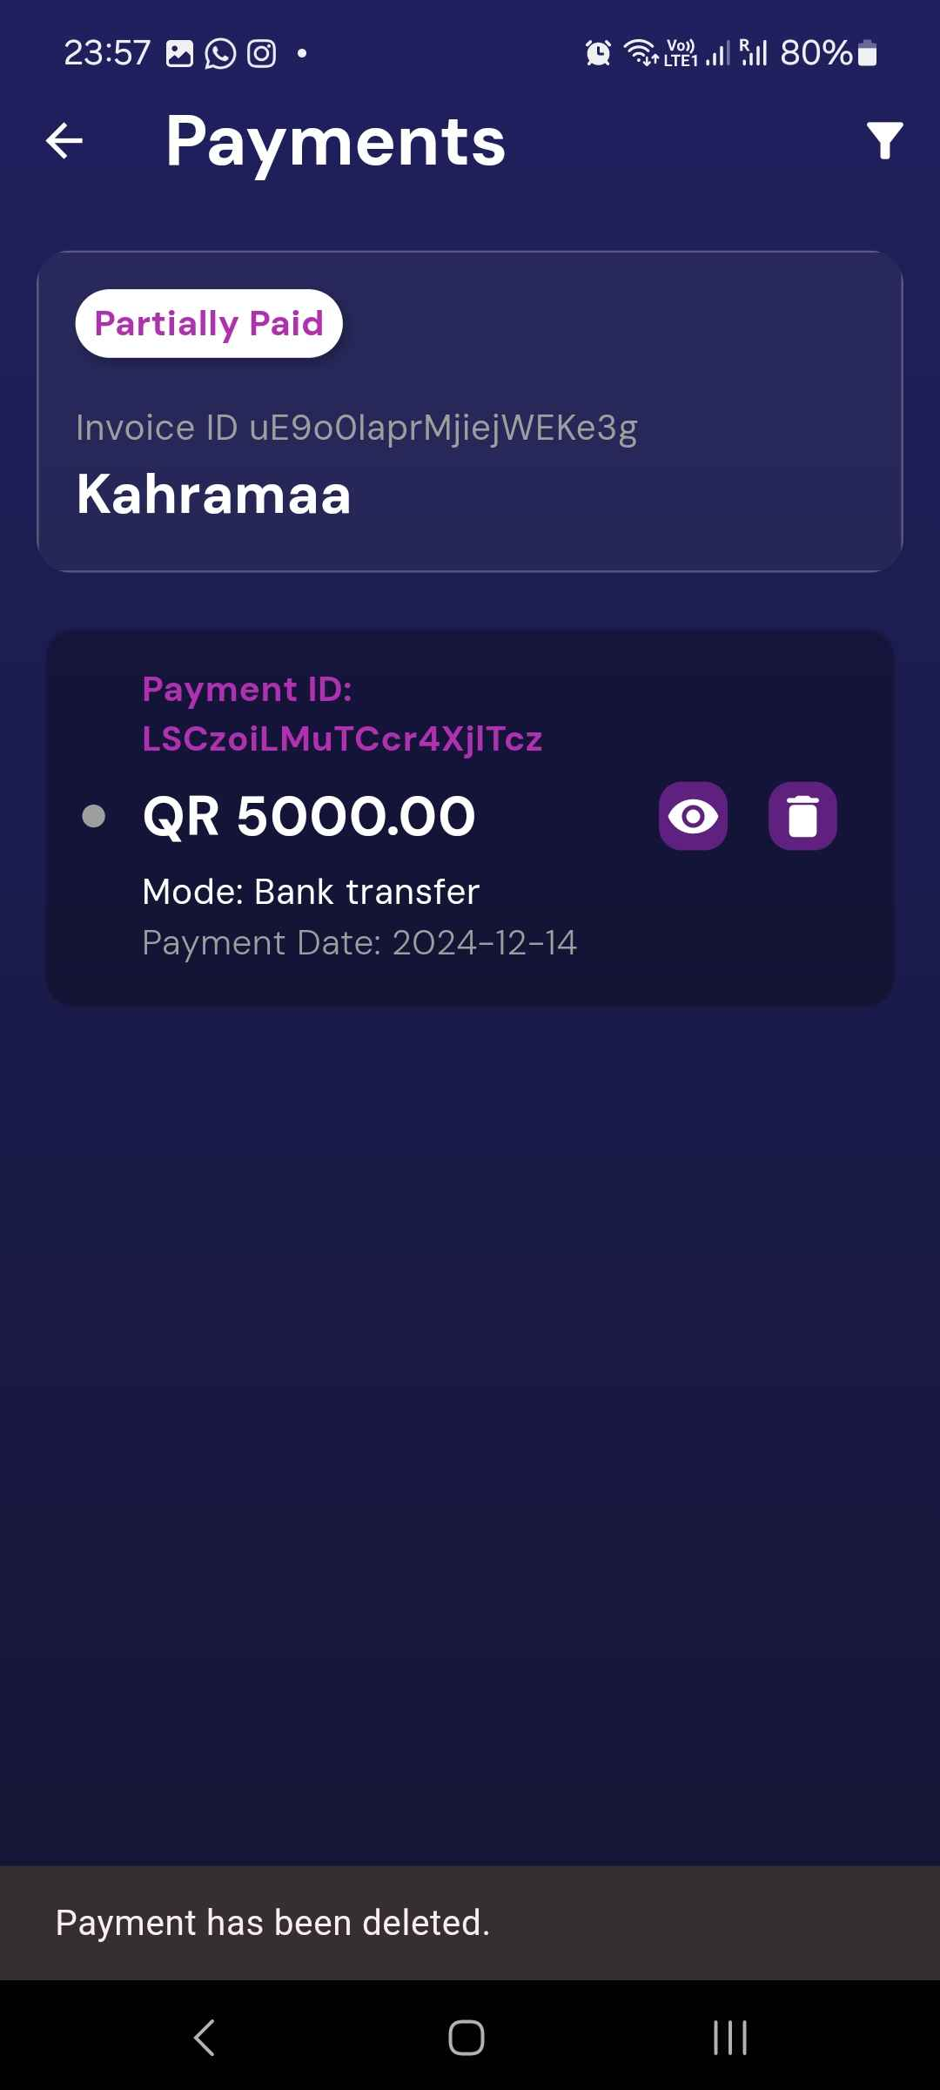

# 2.3.2 Search Payments

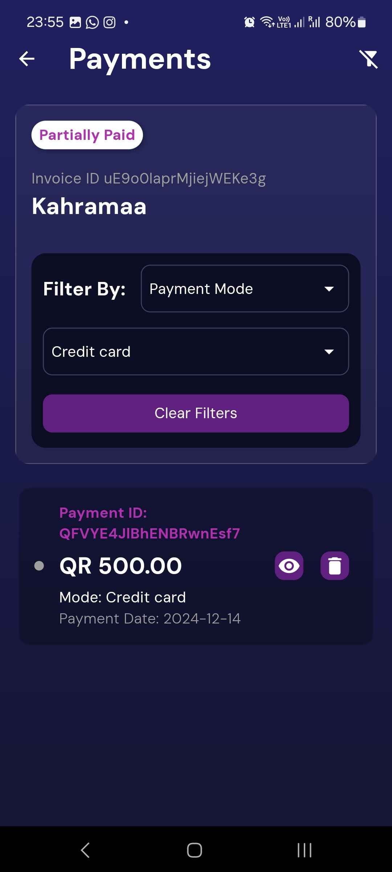

# 2.3.3 Add Payment including attach a cheque image

NOT COMPLETELY WORKING (attaching cheque image)

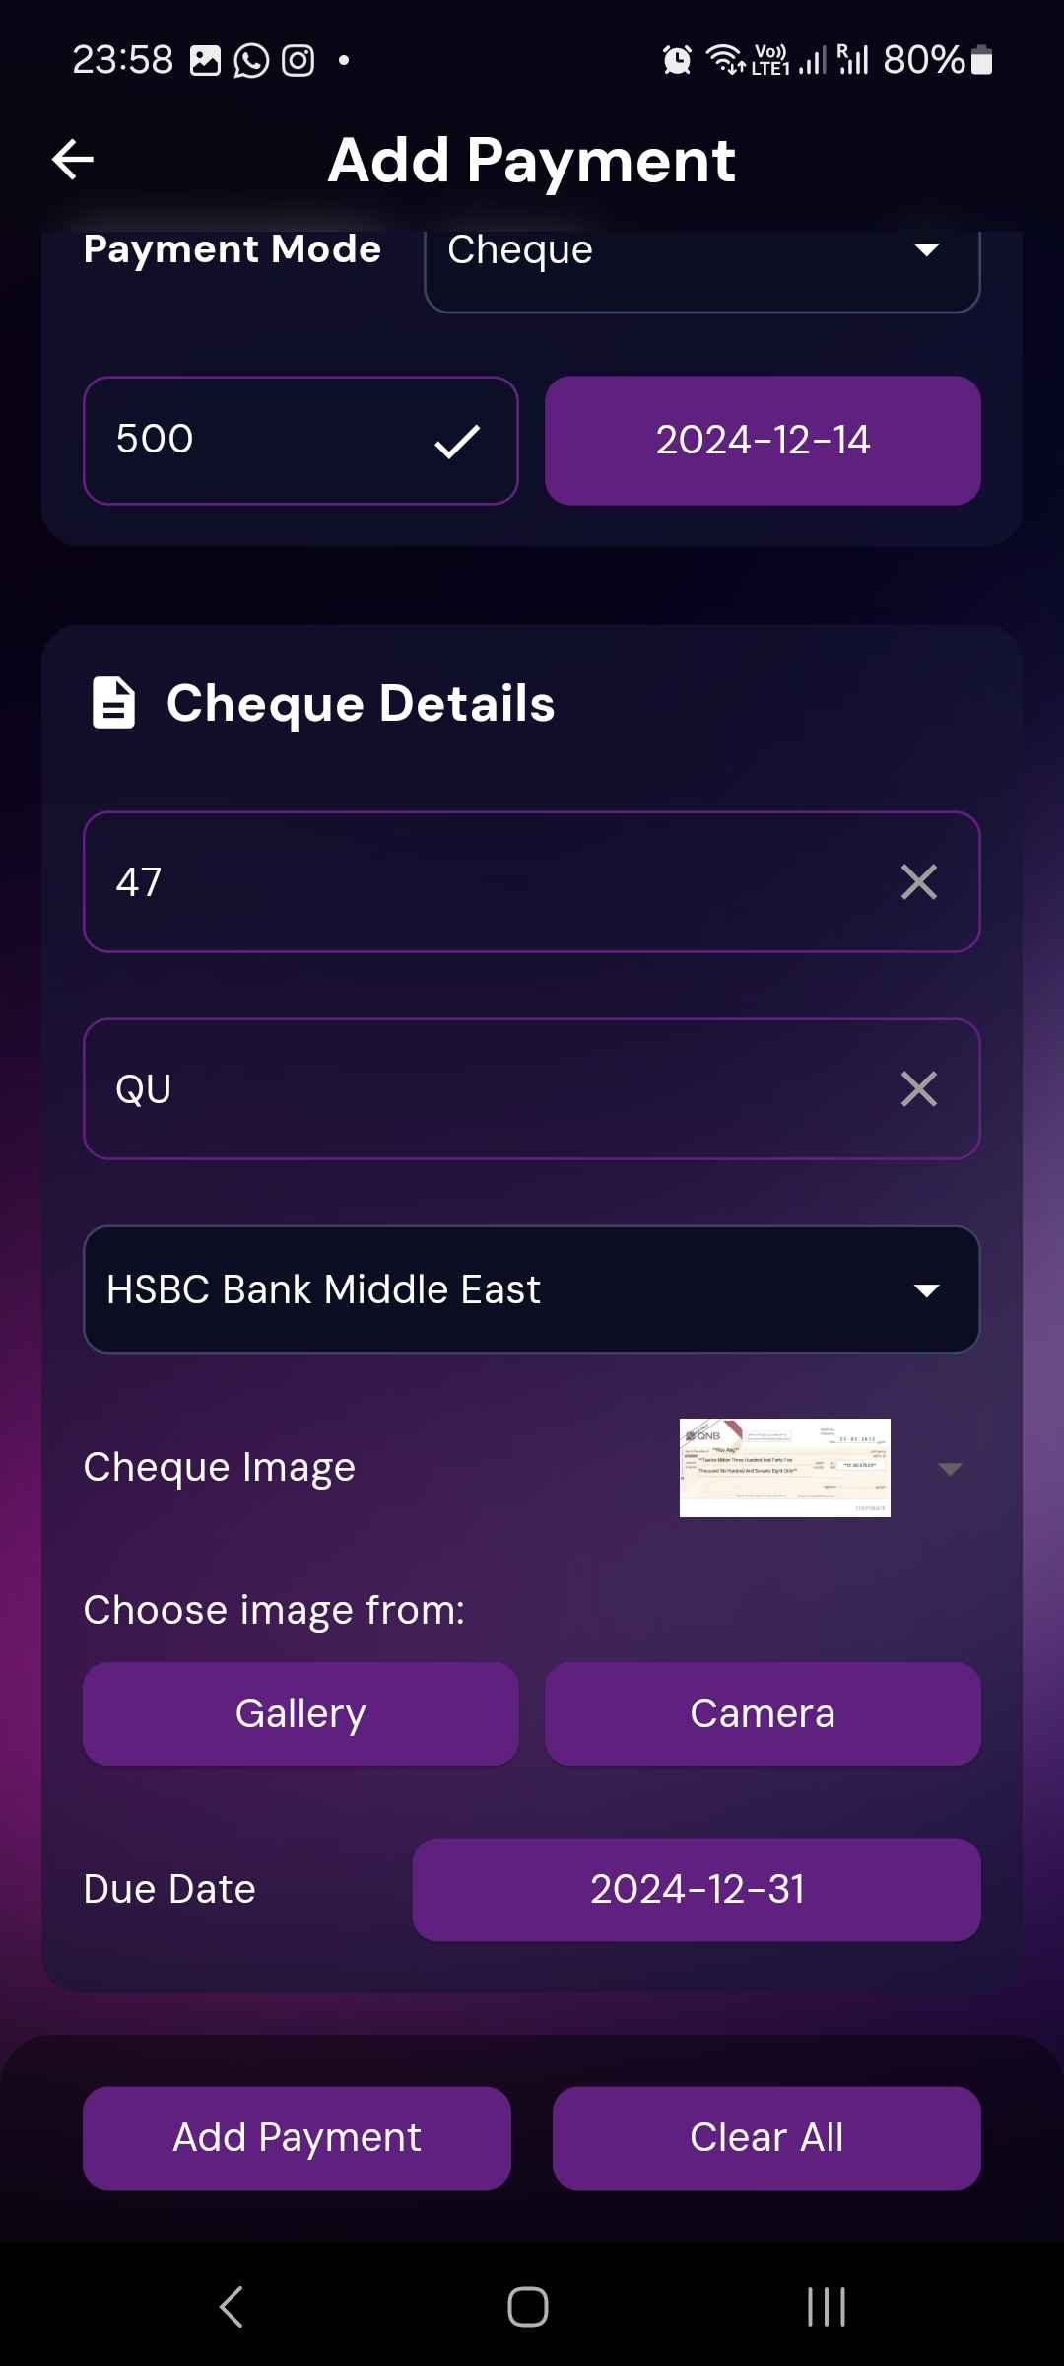

# 2.3.4 Update Payment including attach a cheque image

NOT COMPLETELY WORKING (attaching cheque image)

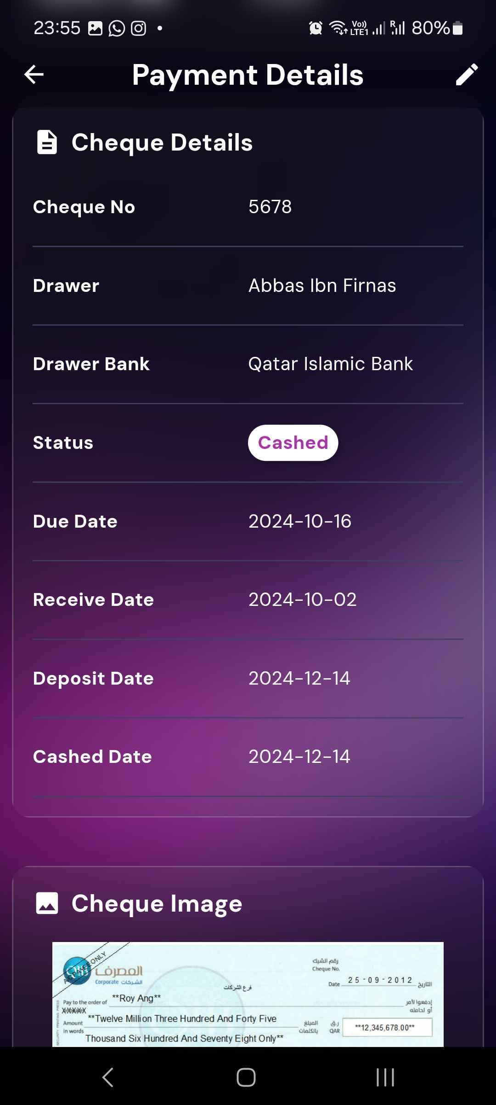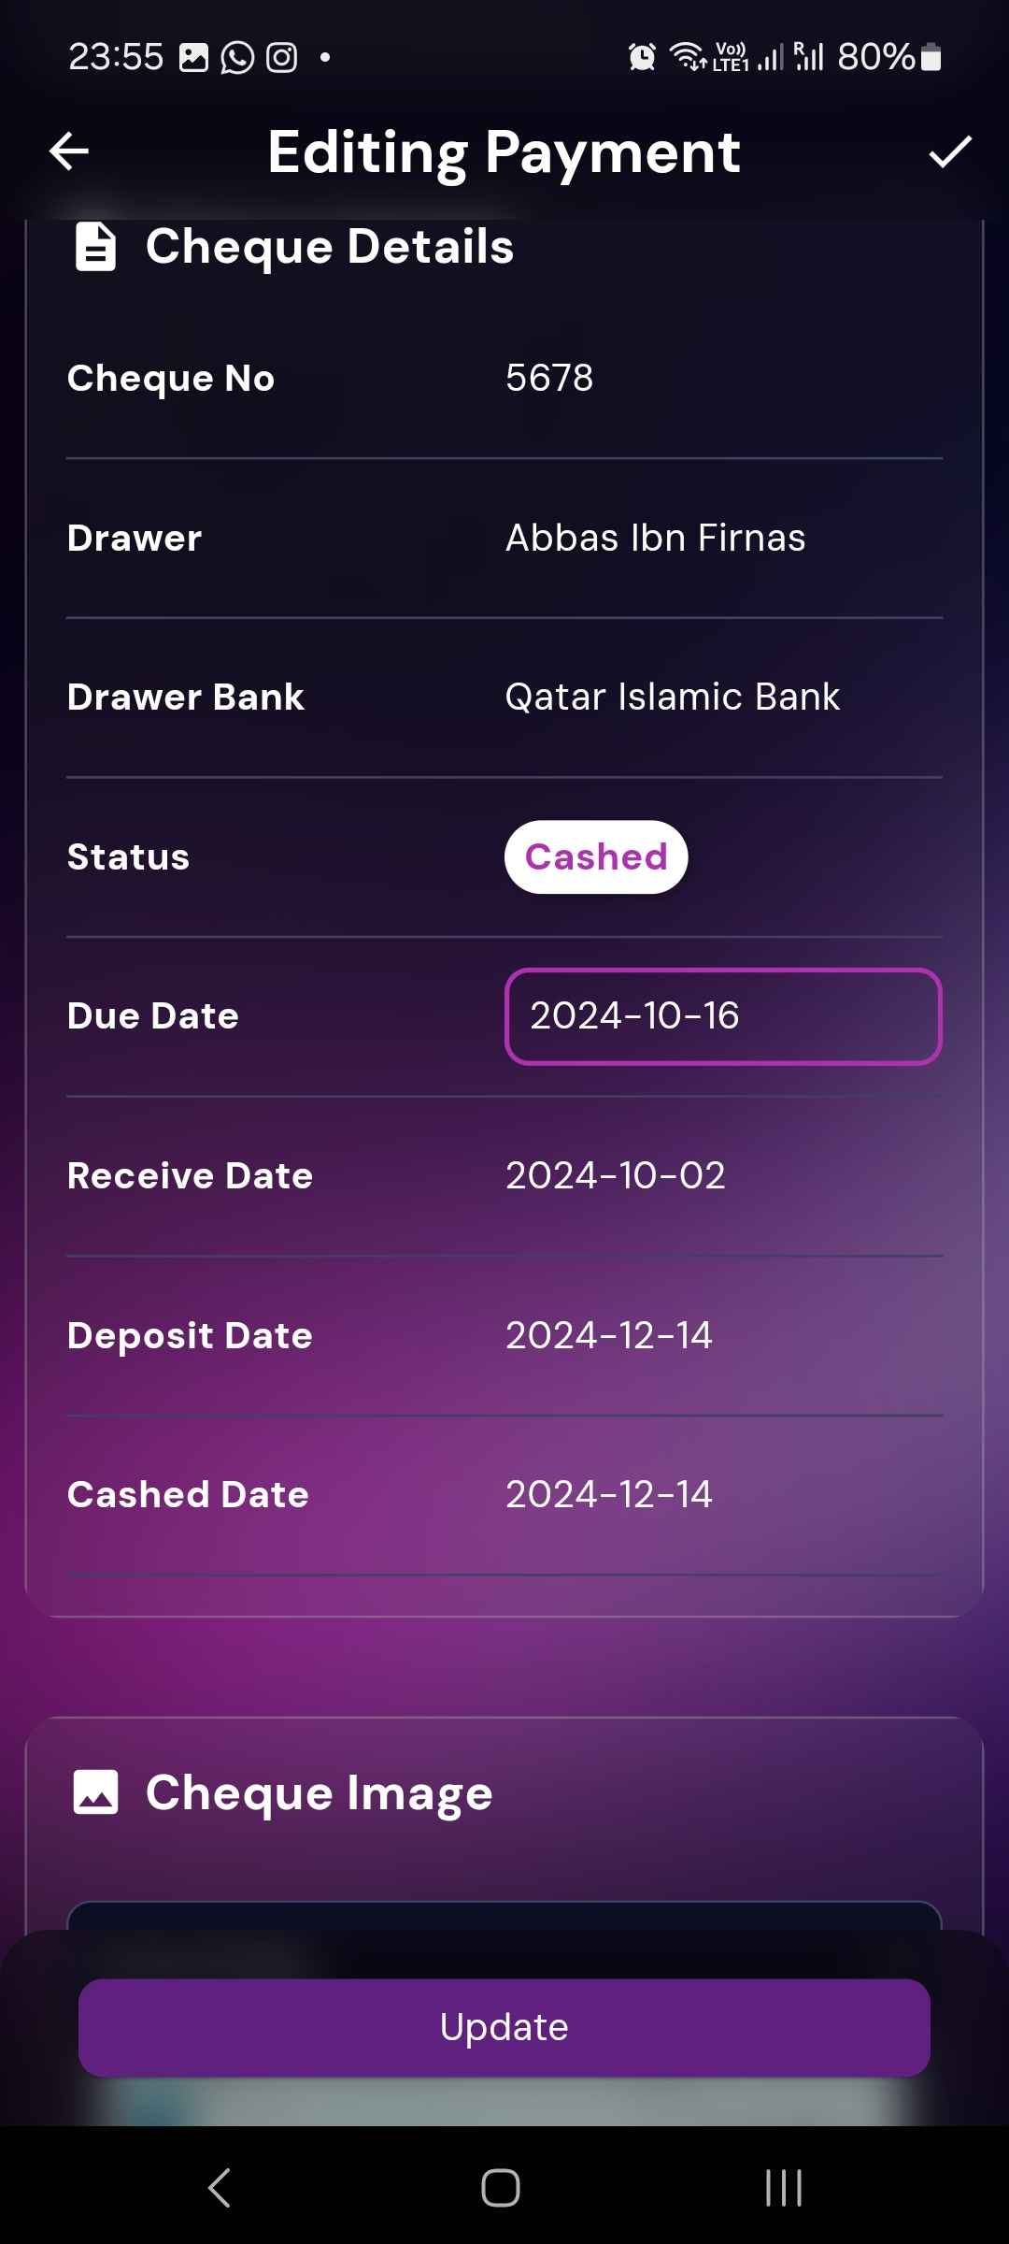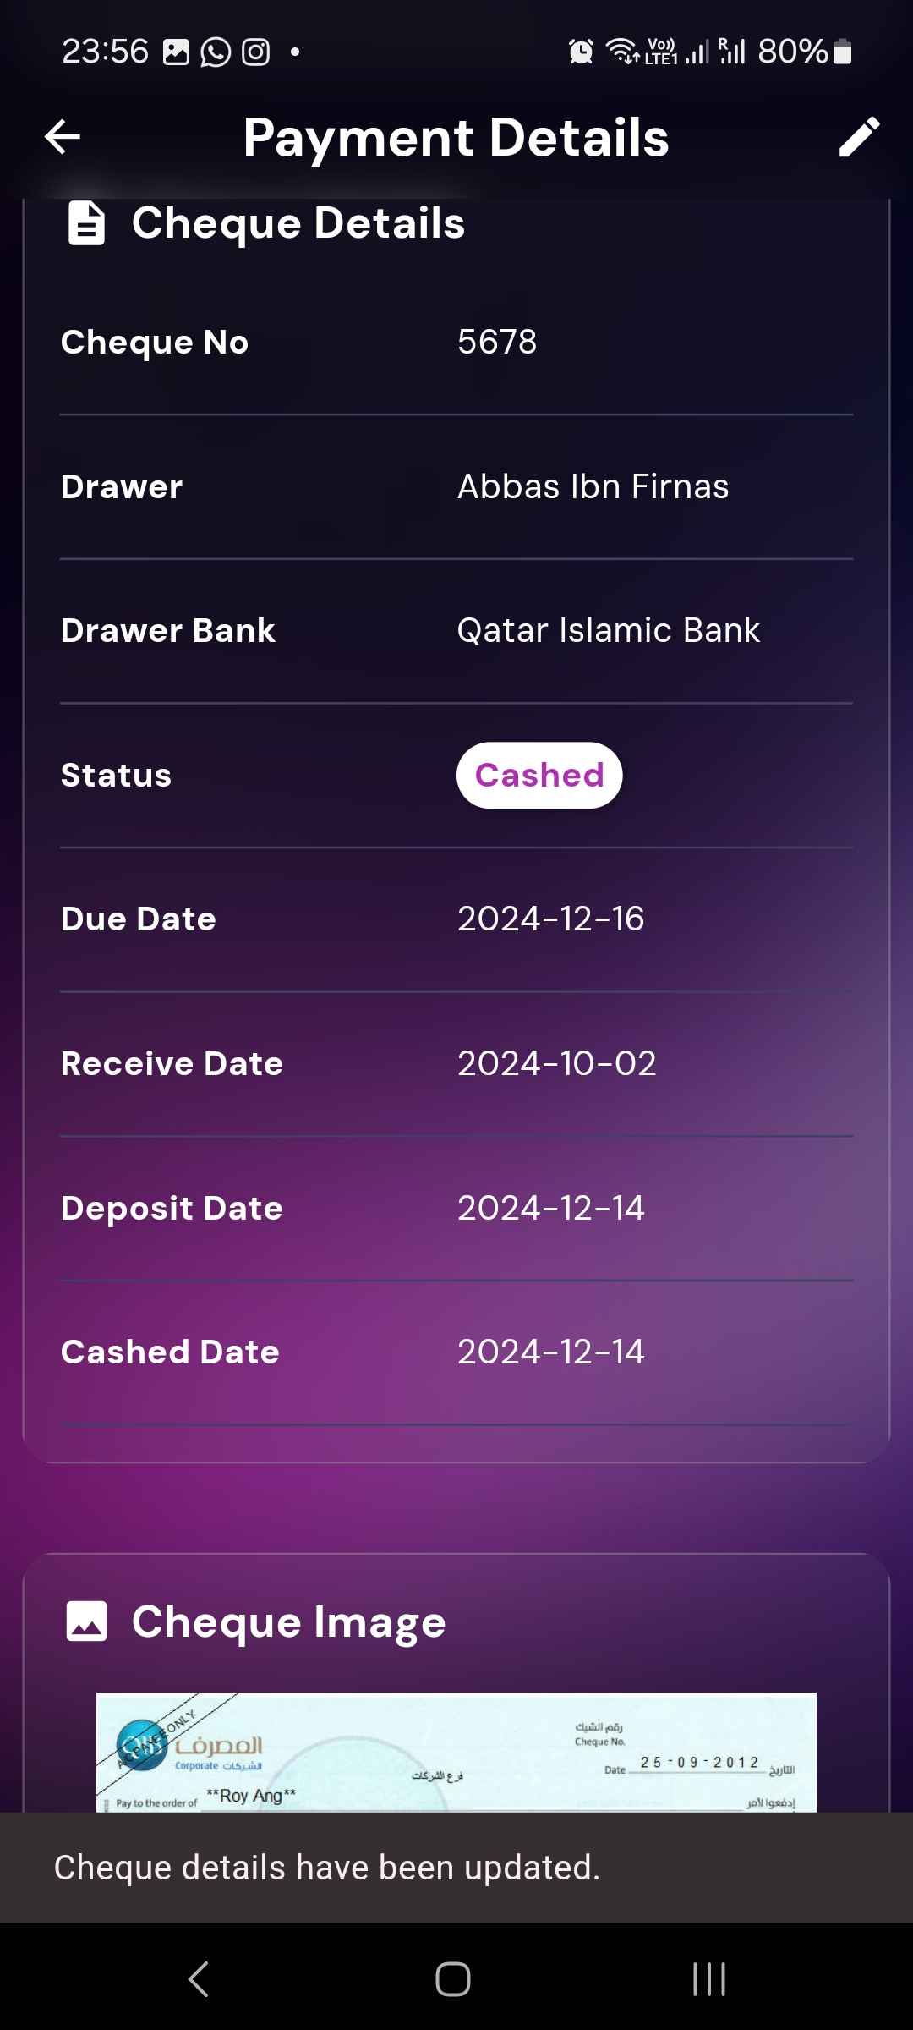

# 2.3.5 Delete Payment

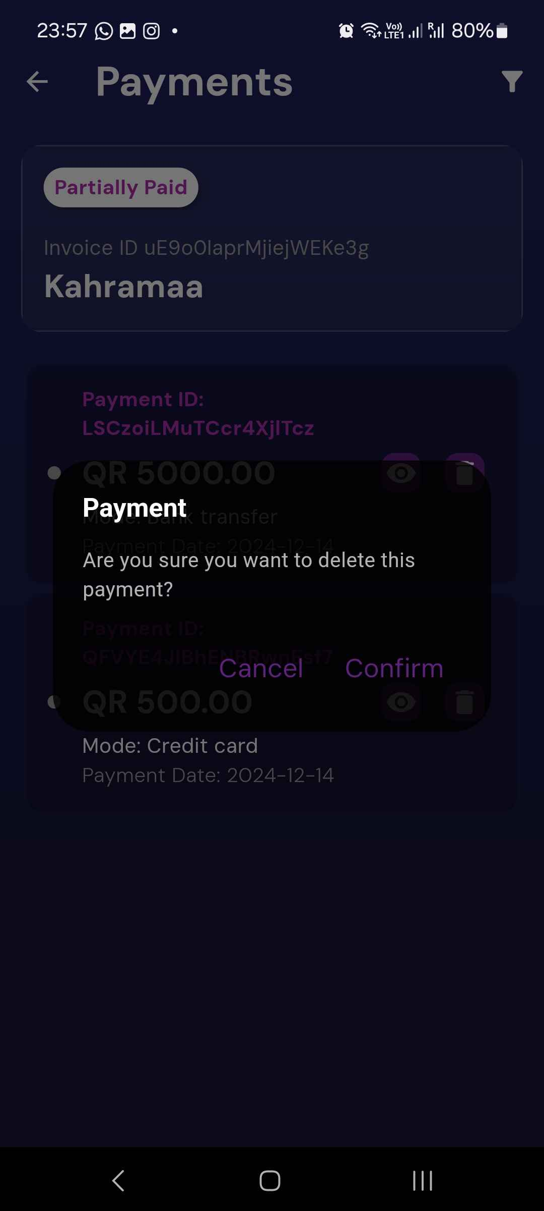

# 2.4 U6 - Manage Cashing Cheques

# 2.4.1 Add Cheques Deposit

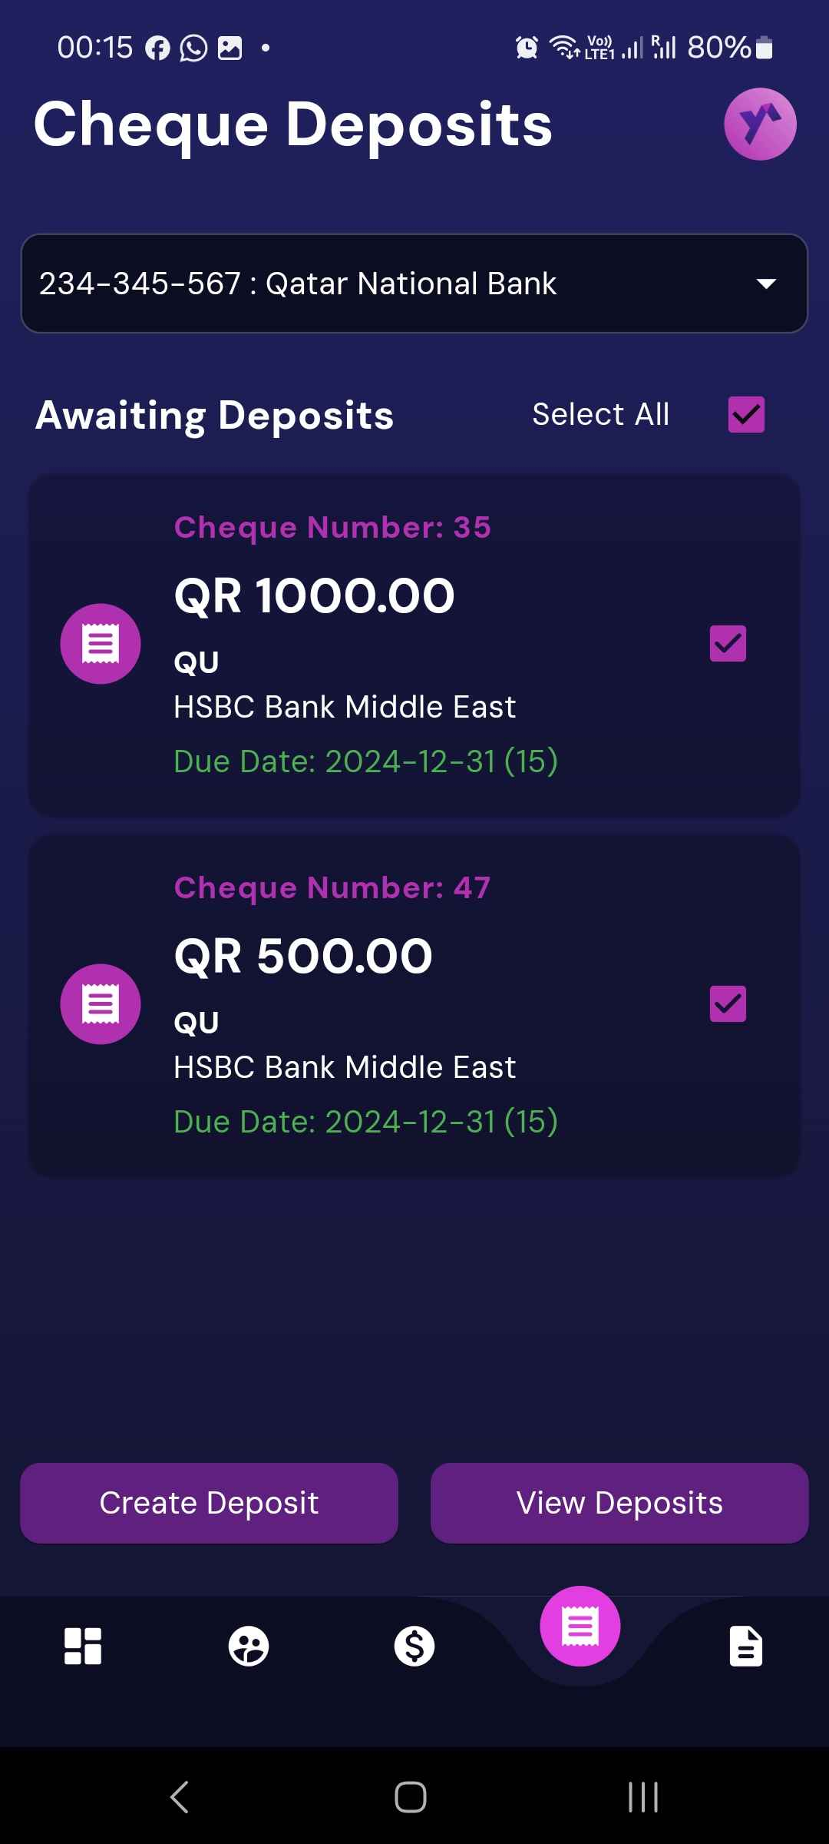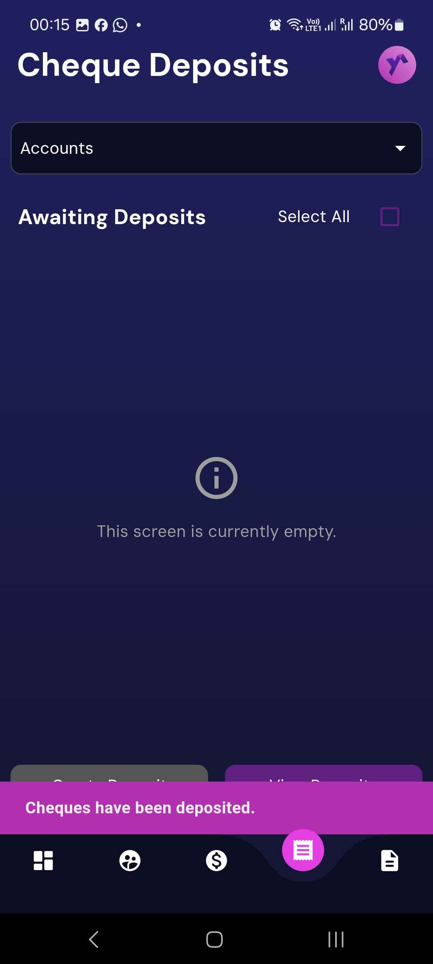

# 2.4.2 List Cheque Deposits

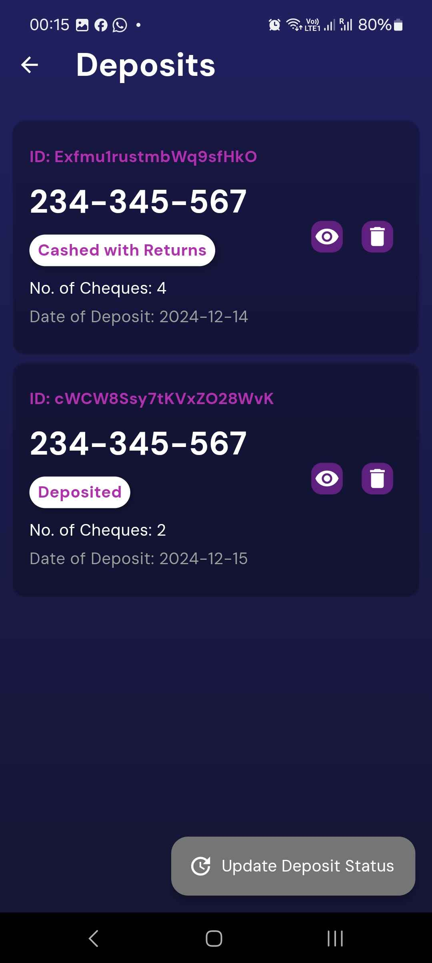

# 2.4.3 Update Cheques Deposit

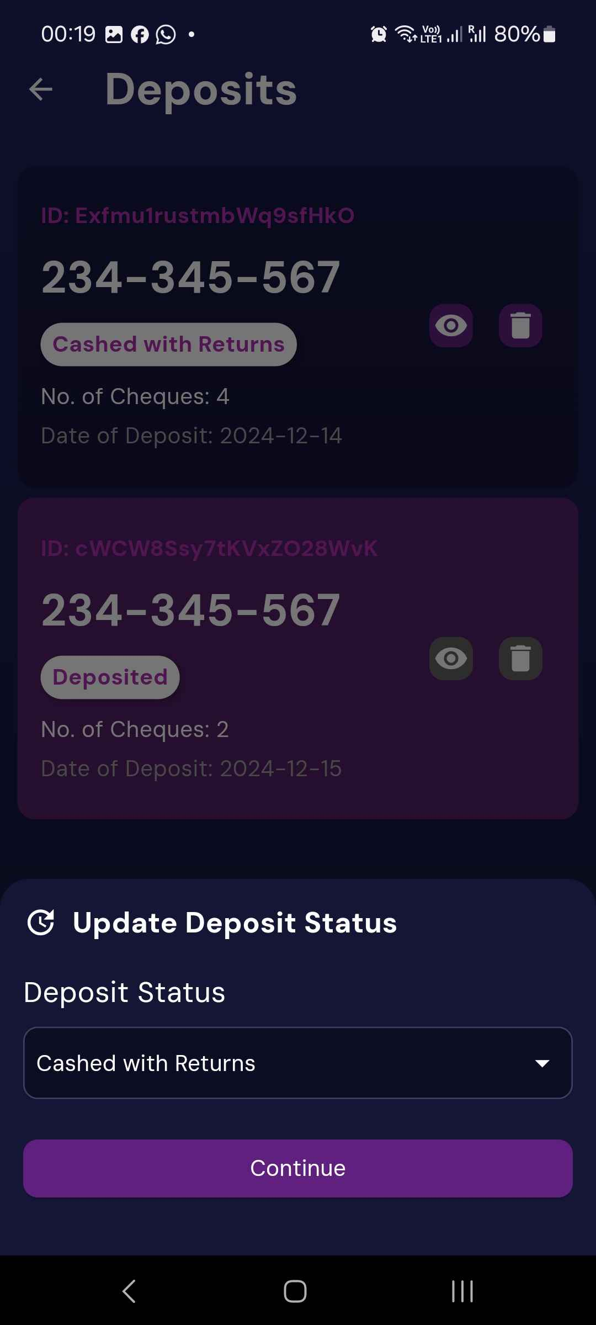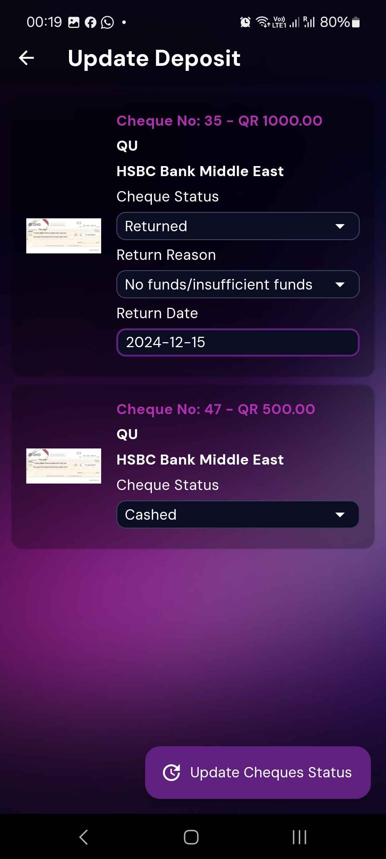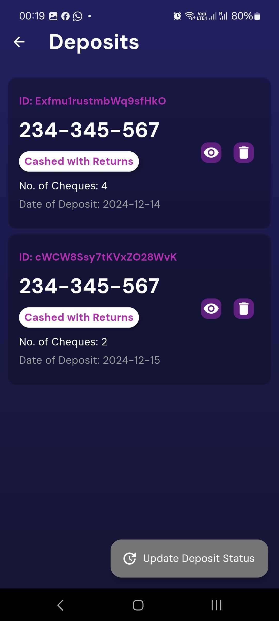

# U7 - Invoices Report

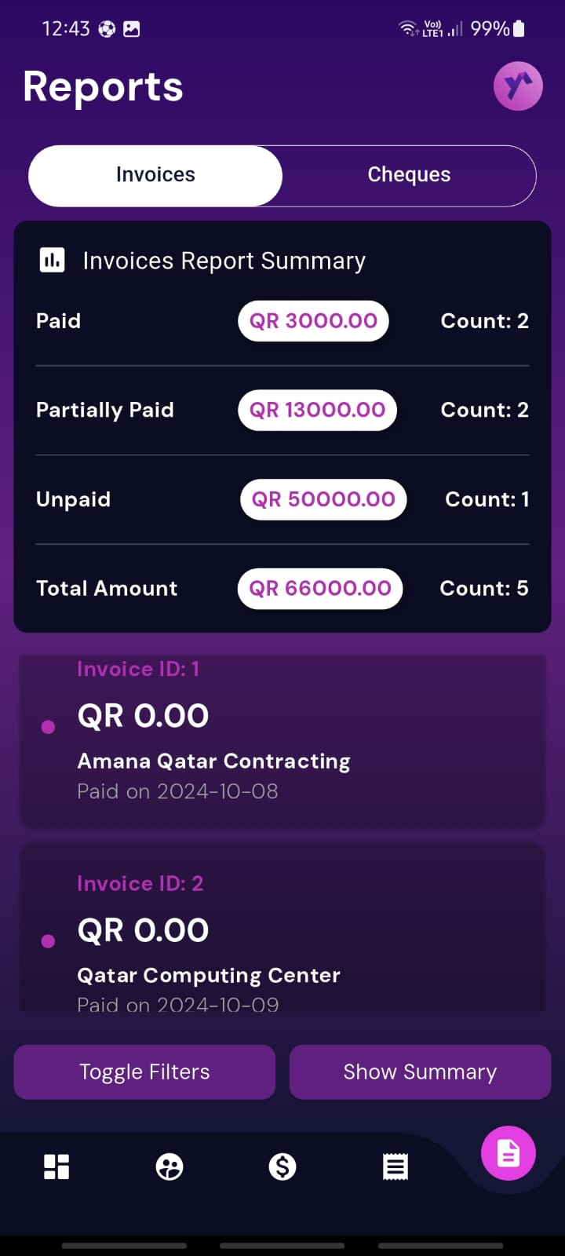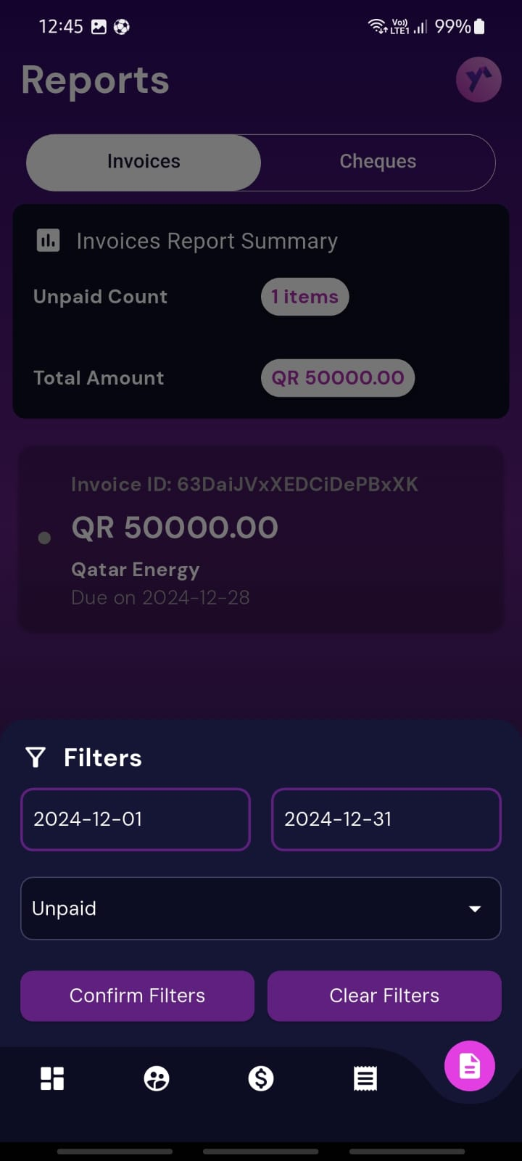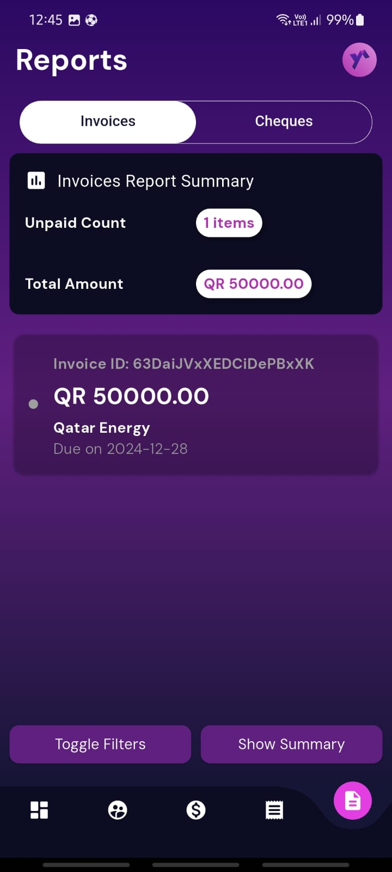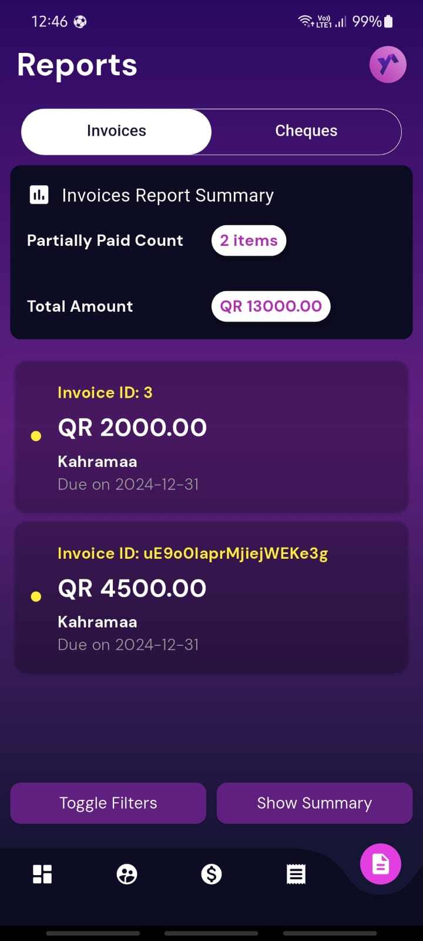

# U8 - Cheques Report

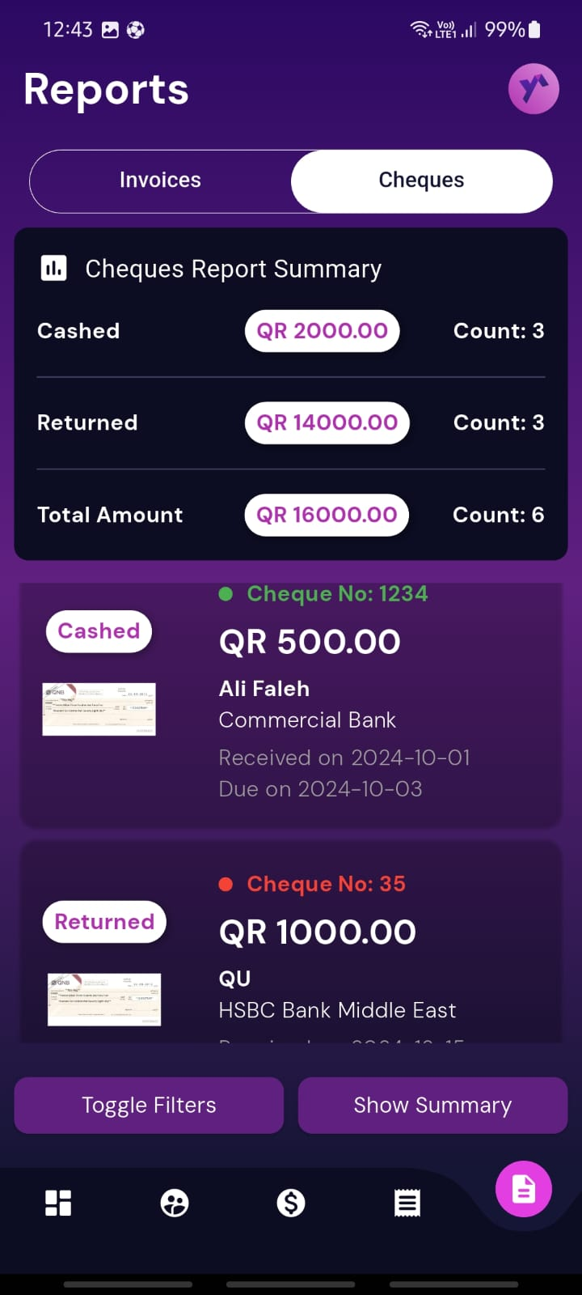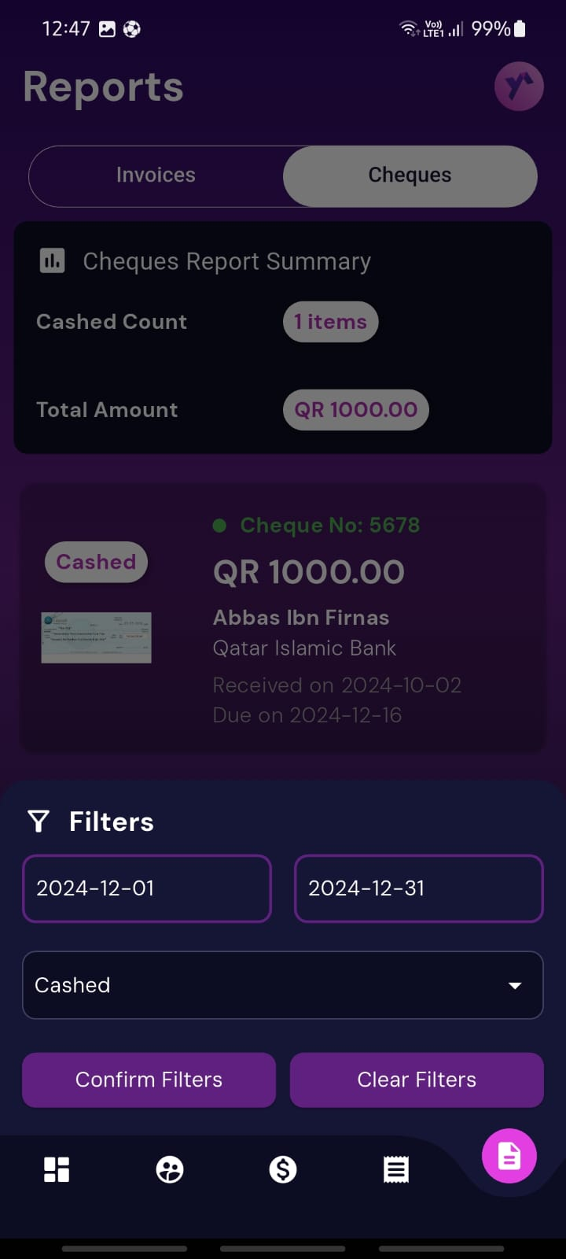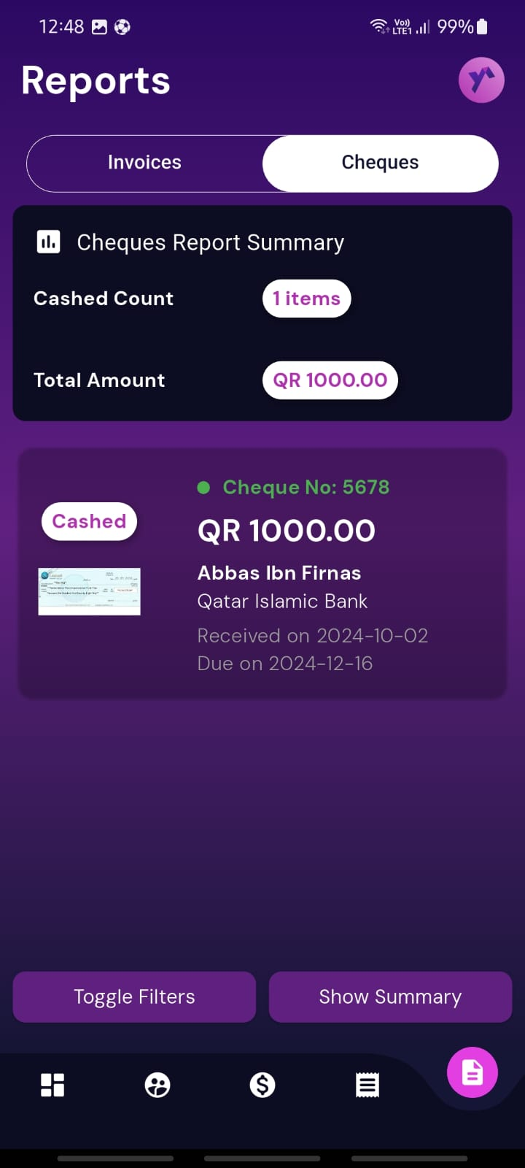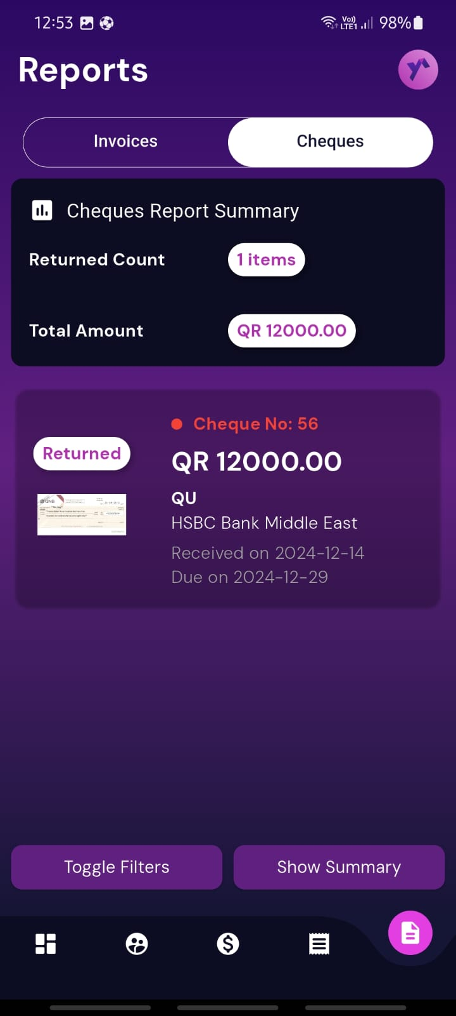

# Summary of team member contributions

|  |  |
| --- | --- |
| 1. **Member** | **Completed use cases / tasks** |
| Fahrel Hidayat | Assisted in implementing SQLite, and updated use cases 2,3,4,5,6 to work with firebase, Designed Schema and conducted Testing. |
| Mohd Bashar | Implemented the repository methods for classes to manage data using firestore database, modified providers, functionality of adding cheque image from gallery/camera. |
| Marcus Monteiro | Managed authentication service in Firebase, added registration screen and validated sign-in, sign-out, and logout functionalities. Updated UI across use cases. |
| Mohammed Alam | Modified classes to entities, made the dao classes , implemented the repo class, implemented the sql lite database. |